|  |  |
| --- | --- |
| **Ex. No. 6** | **JavaScript Styles and Animation** |
| **Date of Exercise** | 06.09.2023 |

**Aim**

To create a javascript styles and animation using html, css and javascript.

**Description**

* alignContent - Sets or returns the alignment between the lines inside a flexible container when the items do not use all available space.
* alignItems - Sets or returns the alignment for items inside a flexible container.
* alignSelf - Sets or returns the alignment for selected items inside a flexible container.
* animation - A shorthand property for all the animation properties below, except the animationPlayState property.
* background - Sets or returns all the background properties in one declaration.
* backgroundAttachment - Sets or returns whether a background-image is fixed or scrolls with the page.
* backgroundColor - Sets or returns the background-color of an element.
* backgroundImage - Sets or returns the background-image for an element.
* JavaScript can be used to move a number of DOM elements (<img />, <div> or any other HTML element) around the page according to some sort of pattern determined by a logical equation or function.
* setTimeout(function, duration) − This function calls function after duration milliseconds from now.
* setInterval(function, duration) − This function calls function after every duration milliseconds.
* clearTimeout(setTimeout_variable) − This function calls clears any timer set by the setTimeout() functions.

**Program**

1)

<!DOCTYPE html>

<html lang="en">

<head>

<meta charset="UTF-8">

<meta name="viewport" content="width=device-width, initial-scale=1.0">

<title>Document</title>

<script src="ex_6_a.js"></script>

<style>

div{

background-color: blue;

color:white;

width:300px;

height:300px;

border:1px solid red;

margin:auto;

}

</style>

</head>

<body>

<div id="box">

Welcome to JS

</div>

<br>

Select Background-Color

<input type="color" onchange="changeBGColor(this.value)"><br><br>

Select Text-Color

<input type="color" onchange="changeTextColor(this.value)"><br><br>

Text Size

<input type="number" onchange="changeSize(this.value)" mix="0" max="50" placeholder="20"><br><br>

Box width

<input type="text" onkeyup="changewidth(this.value)" ><br><br>

Box height

<input type="text" onkeyup="changeheight(this.value)"><br><br>

Border Radius

<input type="range" onclick="changeradius(this.value)">

</body>

</html>

function changeBGColor(a){

var element = document.getElementById('box');

element.style.backgroundColor = a;

}

function changeTextColor(b){

var element = document.getElementById('box');

element.style.color=b;

}

function changeSize(b){

var element = document.getElementById('box');

element.style.fontSize=b+"px";

}

function changewidth(b){

var element = document.getElementById('box');

element.style.width=b+"px";

}

function changeheight(b){

var element = document.getElementById('box');

element.style.height=b+"px";

}

function changeradius(b){

var element = document.getElementById('box');

element.style.borderRadius=b+"%";

}

2)

<!DOCTYPE html>

<html lang="en">

<head>

<meta charset="UTF-8">

<meta name="viewport" content="width=device-width, initial-scale=1.0">

<title>Document</title>

<script src="ex_6.js"></script>

<style>

#b1{

width:1000px;

height:250px;

margin-top:50px;

}

.i1{

width:200px;

height:200px;

}

#b2{

width:75px;

height:200px;

background-color:blue;

float:left;

z-index: 3;

right:100px;

top:19px;

position:absolute;

}

#b3{

width:100px;

height:50px;

background-color:red;

float:left;

z-index: 3;

right:40px;

top:175px;

position:absolute;

}

</style>

</head>

<body onload="init()">

<div id="b1">

<img src="volks.jpeg" id="i1">

</div>

<div id="b2"></div>

<div id="b3"></div>

<button class="start" onclick="move()">Start</button>

<button class="stop" onclick="stop()">Stop</button>

<button class="reset" onclick="reset()">Reset</button>

</body>

</html>

car = null

timer = null

danger = null

function init(){

car = document.getElementById('b1');

car.style.position='relative';

car.style.left='2px';

car.style.top='2px';

}

function move(){

car.style.left = parseInt(car.style.left)+2+"px";

timer = setTimeout(move,10);

if(parseInt(car.style.left)>='1000'){

clearTimeout(timer)

danger = document.getElementById('b3');

document.getElementById('b3').innerHTML='Danger';

}

}

function stop(){

clearTimeout(timer)

}

function reset(){

car.style.left='2px';

danger.style.background = 'none';

document.getElementById('b3').innerHTML='';

}

**Output**

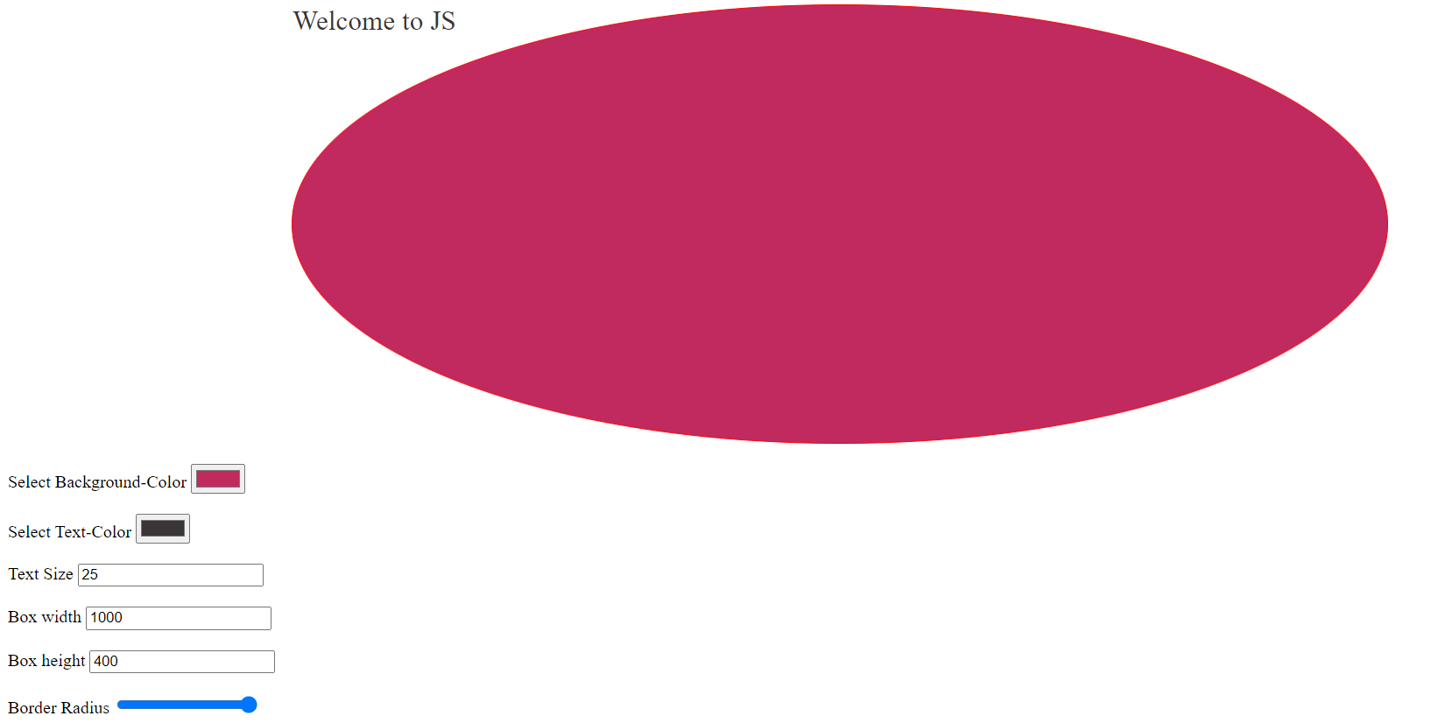

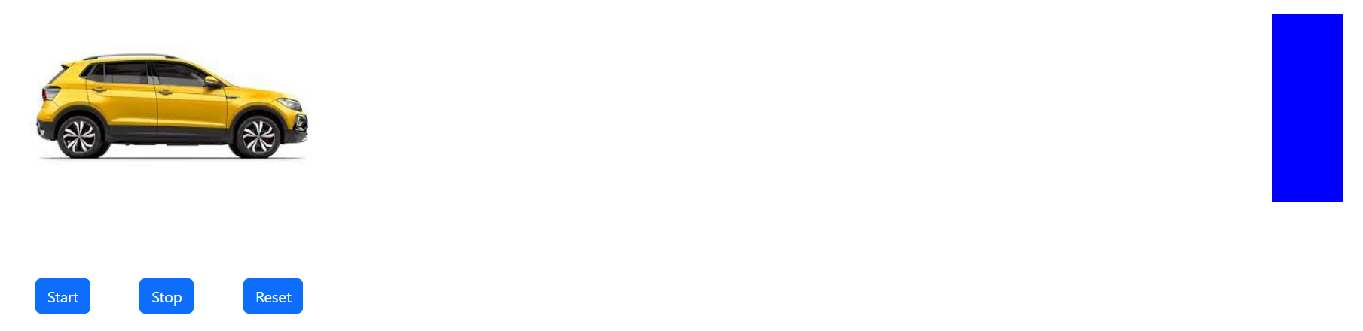

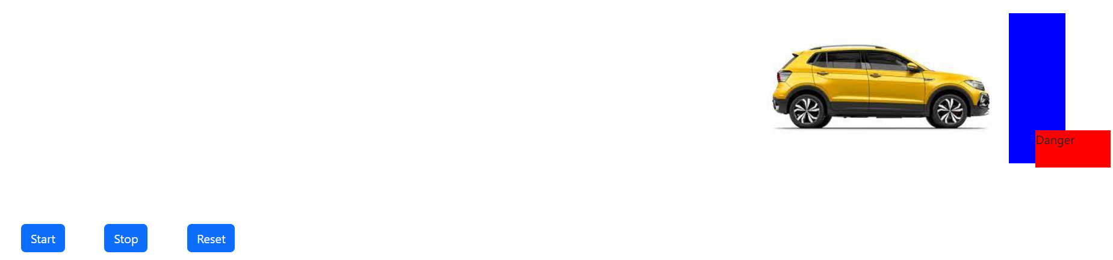

**Result**

The program is executed successfully and the program output is displayed in the web browser.